Green Dot Cyprus Membership Agreement
The present agreement is compiled today ………………………, in between:

- GREEN DOT (CYPRUS) PUBLIC CO LIMITED, a not for profit company incorporated with the initiative of the Cyprus Chamber of Commerce and Industry under Cyprus law, having its registered office at 229 Tseriou Av., 2047, Strovolos, Nicosia, and with company registration number 139858, whereby said company is referred to hereafter as “Green Dot Cyprus”,

and:

- , a company incorporated under the laws of , having its registered office at

and with company
registration number _ _______. Said company is referred to hereafter as the
“Packaging Responsible”.

WHEREAS:

- The European Parliament and Council Directive 94/62/EC of 20th December 1994 and 2004/12/EC of 11th February 2004, on packaging and packaging waste has been transposed into Cypriot legislation by means of “the Packaging and Packaging Waste Ordinance of 2002”, enacted on 12th of April 2002 and revised later on (hereafter “the Law”) by means of the regulations based on this law (hereafter “the Regulations”).

- By virtue of the Law, packagers and importers of packed goods are responsible to collect and sort packaging waste and ensure that such waste is directed to recovery or to authorised treatment facilities. The Packaging Responsible is obliged to deal with the management of the packaging derived from its operations by either organising an individual packaging waste management system or by participating in a collective packaging waste management system. By participating in an authorised collective system and the observance of its obligations towards the System, the Packaging Responsible is relieved from any other responsibility for its packaging and the respective responsibility is transferred to the collective system it participates in.

- After considering the advice of the Advisory Committee for the Management of Packaging Waste, the Minister of Agriculture, Rural Development and Environment has approved Green Dot Cyprus as a collective packaging and packaging waste management system (hereafter called “the System”) in accordance with the Law. The accreditation of Green Dot Cyprus is valid from the 30th of June 2020, to the 30th of June 2026, and can be renewed for successive six year periods with a request submitted to the authorities at least six months before each accreditation expires.
Initials

- Packaging Recovery Organisation Europe s.p.r.l., a company having its registered office at Avenue des Olympiades 2, 1140 Bruxelles, Belgium (hereafter called “PRO EUROPE”) has granted an exclusive licence to Green Dot Cyprus for the use of Green Dot Mark and the right to grant sub-licences in Cyprus for an indefinite period. Green Dot Cyprus is agreeable to grant a right of use of the Green Dot Mark on the terms & conditions specified hereinafter.

- In view of the above, the Packaging Responsible wishes, in order to fulfil its obligations provided by the Law, to participate in the System that is set up by Green Dot Cyprus in accordance with the terms and conditions described in this Agreement.

In view of the foregoing, it has been agreed as follows. Article 1. Definitions
  - “Agreement”
means the present document, as signed, together with any modifications and additional elements that may later be agreed.

  - “Law”
means the “Packaging and Packaging Waste Ordinance of 2002” and any other
relevant laws and regulations enacted or to be enacted.

  - “Competent Authorities”
means the Minister of Agriculture, Rural Development and Environment.

  - “Packaging”
means every product made of any materials of any nature, intended to be used for the containment, protection, transport, delivery and presentation of goods, ranging from raw materials to processed goods, from the producer to the user or the consumer and shall include all “disposable” items used for the same purpose. A more extensive definition of packaging is given in the Law.

Packaging consists of:
    - sales packaging or primary packaging meaning packaging conceived so as to constitute a sales unit to the final user or consumer at the point of purchase;
    - grouped packaging or secondary packaging meaning packaging conceived so as to constitute at the point of purchase, a grouping of a certain number of sales units whether the latter are sold as such, to the final user or consumer, or whether they serve only to replenish the shelves at the point of sale and can be removed from the product without affecting its characteristics;
    - transport packaging or tertiary packaging, meaning packaging conceived so as to facilitate handling and transport of a number of sales units or grouped packaging, in order to prevent physical handling and transport damage, but does not include road, rail, ship and air containers.

Article 2. Purpose of the Agreement

The purpose of the Agreement is the participation in the System set up by Green Dot Cyprus and the fulfilment by the Packaging Responsible of its obligations provided by the Law. Therefore, the Agreement describes:

- the conditions for participating in the System set up by Green Dot Cyprus and by the Competent Authorities issuing the accreditation.
- the terms concerning the use of the Green Dot Mark as specified by PRO Europe and Green Dot Cyprus.

When a Packaging Responsible is participating in the System, the System is not automatically obliged to undertake the collection of, either part, or all of the packaging that the Packaging Responsible places in the market, or found in his premises, or other premises, or from the consumers. The System retains always the right, in cooperation with the Competent Authorities, to define the target materials for collection, taking into consideration the recovery and recycling targets that need to be covered. As a Packaging Collective System for packaging waste, the System is obliged to recover and recycle the quantities provided by the Law, collectively for all the Packaging Responsibles it represents and not for each one separately.

Article 3. Territory

This Agreement is entered into force in the Cypriot territory – Area controlled by the Republic of Cyprus (hereinafter called “the Territory”). This means that the responsibility undertaken by Green Dot Cyprus on behalf of the Packaging Responsible is strictly limited to the products placed by the latter in the local market (the Territory).

Article 4. Declaration of packaging data

  - For the purpose of enabling Green Dot Cyprus to fulfil its obligations according to this agreement and/or the Law and Regulations, the Packaging Responsible shall provide Green Dot Cyprus, no later than 28 February of each year, with a Declaration of the actual amount of packaging placed by it on the market in the preceding year
(hereafter called “the Declaration”). The first Declaration shall be provided within two months after signing of the Agreement.

  - The format of the Declarations have been decided by Green Dot Cyprus, have been or will be approved by the Competent Authorities and are accepted by the Packaging Responsible. These formats are included in Annex I of the Agreement. Green Dot Cyprus has the right to change the format of the Declarations and shall inform the Packaging Responsible of any format changes at least two months before the end of each year. It is understood that, any Declaration formats or any changes in the above- mentioned Declarations should be effected according to the Law and Regulations. The data required to fill in the Declarations will be limited to those that Green Dot Cyprus considers extremely essential to conform to the Law and relative Regulations.
Initials

There are three types of Packaging Declarations:

Detailed Declaration & Detailed Declaration Pesticides
    - Catalogue Declaration & Catalogue Declaration for Drinks
    - Declaration with Categorization

In order for a company to complete the Declaration with Categorization it must have completed for the year before, either the Detailed Declaration or the Catalogue Declaration, to serve as a reference year. If a company utilize Declaration with Categorization, it is entitled to continue to do so for a maximum of three years. After the three years, the company must complete again the Detailed Declaration, or the Catalogue Declaration, for confirmation, or for a change of the category that the company belongs to.

  - Green Dot Cyprus undertakes to maintain full confidentiality of the packaging data communicated to it directly by the Packaging Responsible, or of which Green Dot Cyprus might acquire knowledge in the implementation of the Agreement. This confidentiality closure implies that no financial or commercial or other information will be communicated to other members, to shareholders or to any other party, without prejudice to the obligations that Green Dot Cyprus may have vis-à-vis the public or other governmental authorities or any other person invested with a special power by virtue of any act of legislative provision whatsoever to provide them with certain information.

  - Every Declaration shall be certified correct by the representative under the law of the Packaging Responsible and every second year by the external certified auditors of the Packaging Responsible. This certification shall be done at the expense of the Packaging Responsible.

4.05 Green Dot Cyprus is entitled to undertake any checks necessary (giving proper notification to the Packaging responsible) to ensure that the Declaration of the packaging data is correct. Green Dot Cyprus reserves the right to undertake these checks either by its own staff, or to employ a certified external auditor bound by professional confidentiality to undertake the checks. The costs of such checks shall be borne by Green Dot Cyprus. Additionally, the Competent Authorities retain also the right to conduct such checks directly.

Article 5. Registration Fees

  - A Packaging Responsible enrolling as a Member with the signing of this
Agreement, shall pay as a registration fee the amount of €850 plus VAT, in case the packaging placed in the market by the Packaging Responsible the year before exceeds the amount of five tonnes, in total. If the packaging placed in the market by the Packaging Responsible is between two and five tonnes in total, then the Packaging
Responsible shall pay as a registration fee the amount of €400 plus VAT. If the packaging placed in the market by the Packaging Responsible is less than two tonnes in total, then the Packaging Responsible shall pay as a registration fee the amount of
€50 plus VAT

If the first Detailed Declaration of the Packaging Responsible proves that the registration fee that was paid was not the correct one according to the rules above, as explained above, then depending on the arising difference, the company will be invoiced for the additional amount, or will be refunded for it. This fee is intended for the sharing of the initial set-up costs of the organisation between all the members and to cover Member initial registration costs. The registration fees are non-refundable.

  - A Packaging Responsible, who is already a Shareholder of Green Dot Cyprus and has contributed to the share capital with the sum of €3,420, shall pay to Green Dot Cyprus, as a registration fee upon signing of this Agreement, the nominal amount of
€1.71.

Article 6. Funding Contributions

  - In order to enable Green Dot Cyprus to fulfil its obligations, the Packaging Responsible shall pay to Green Dot Cyprus annual contributions for financing the System. The contributions apply and shall be paid from the accreditation date of the System, the 1st of August 2006, as explained in Article 7 of this Agreement.

  - The annual contributions concern and will be due for the packaging placed on the market in the Territory by the Packaging Responsible during the year. These contributions shall be based on the quantity and type of packaging, as provided by the Packaging Responsible in its yearly Declaration.

  - For the purpose of this Agreement,
    - year n means the current year during which the Agreement is in force;
    - year n-1 means the year preceding year n;

  - The invoicing and payment of the contributions of the Packaging Responsible to Green Dot Cyprus for year n, shall be based on the packaging quantities placed in the market by the Packaging Responsible in the previous year (year n-1) and shall be due within 30 days from the issue date of the invoice, unless:

Initials

5

- the invoice amount is between €2,000 and €10,000 in which case it
is payable in two (2) equal consecutive monthly instalments
- the invoice amount is between €10,001 and €20,000 in which case
it is payable in three (3) equal consecutive monthly instalments
- the invoice amount is between €20,001 and €35,000 in which case
it is payable in four (4) equal consecutive monthly instalments
- the invoice amount is between €35,001 and €85,000 in which case
it is payable in five (5) equal consecutive monthly instalments
- the invoice amount is beyond €85,001 in which case it is payable in six (6) equal consecutive monthly instalments. In this case, along with the first instalment besides payment of the 1/6 of the clear amount, the total of the VAT should also be paid.

Any delays in payment shall hold an interest equal to the running lending interest rate of the Central European Bank plus 1%.

  - In derogation to the foregoing paragraph, if no Declaration from the Packaging Responsible is available, because the Packaging Responsible has not put any packaging on the market in the preceding years, the advances shall be calculated on the basis of the packaging volumes that the Packaging Responsible anticipates placing on the market during the current year (year n).

  - Payments shall be made by credit transfer or banker’s cheque, or any other means of payment approved by Green Dot Cyprus. All invoices are payable in thirty
(30) days from invoice issue, unless the amount due falls in any of the categories described in article 6.04. The Packaging Responsible will not be validly and entirely freed from its obligation to pay an invoice unless Green Dot Cyprus has received the full amount invoiced. Consequently, for example, bank charges associated with payment method chosen by the Packaging Responsible shall be covered by the Packaging Responsible. Any dispute concerning invoices must be submitted by registered mail within thirty calendar days of the invoice date in order to be valid.

  - The contributions of the Packaging Responsible are calculated based on the weight of the packaging placed in the Territory multiplied by the charges contained in the System Fee Catalogue in Annex II of the Agreement. In order to carry out its assignment, Green Dot Cyprus shall be able, within the limits permitted by the Law and by duly reasoned resolution of the Board of Directors, to revise the System Fee Catalogue, to revise the payment terms and to fix the date on which such revisions shall come into effect.

  - If the Packaging Responsible does not submit its Declaration in due time, it shall be responsible for the delay and shall pay agreed compensation with an amount equivalent to 1% of the annual contribution per month of delay, with a minimum of fifty (€50) Euro per month and a maximum of three thousand five hundred Euro (€3,500) per month. In the event that Green Dot Cyprus after a period of six months, calculated in accordance with article 4.01, has not yet received the Declaration, Green

Dot Cyprus will be legally entitled to dissolve the Agreement in accordance with article 11.

  - In the event that Green Dot Cyprus, by any means available to it under the law and in particular by means of the checks referred to in article 4.05, ascertains that a false statement is contained in the Declaration, the Packaging Responsible shall be obliged to pay to Green Dot Cyprus, on the one hand, the contributions not paid plus interest on the sums due and not paid, calculated at the running legal lending interest rate of the Central Bank of Cyprus plus 5%. In the event of a second breach, Green Dot Cyprus shall automatically be entitled to consider the Agreement terminated.

6.10. The minimum contribution that a Packaging Responsible should pay, is 100.00 euros for the use of Green Dot Mark and its System membership management cost.

Article 7. Use of Green Dot Mark

  - The “Green Dot Mark” (hereinafter “the Mark”) printed on a packaging means that, for such packaging, a financial contribution has been paid for a specific time period to Green Dot Cyprus. The Mark contains no sorting message; it is not related to the recyclability of the packaging and is merely an indication of membership to the Green Dot Cyprus System.

  - The Law and the terms of Accreditation of Green Dot Cyprus impose that package labelling must also refer to:
    - the nature of the material or the packaging materials used, in a manner that will facilitate the classification of the material by an interested industry managing packaging materials according to Annex IV of the Packaging and Packaging Waste Law,
    - the special Mark indicating that the packaging is reported in a collective packaging management system, where applicable.

Green Dot Cyprus provides the Packaging Responsible with a non exclusive Right of Use of the mark (hereinafter called “Right of Use”), allowing and imposing the printing of the Mark only on its primary packaging as provided in the Green Dot Cyprus System Accreditation. The Packaging Responsible has the responsibility to arrange for the correct labelling of its packaging with the Mark as is specified in Annex III of the present Agreement. The labelling should be distinct, legible, durable and long lasting, even after the packaging has been opened.

Initials

7

  - In the event of an amendment to the conditions of use of the Mark by Green Dot Cyprus, such amendments shall be duly communicated by Green Dot Cyprus to the Packaging Responsible in due time and the latter undertakes to abide by any amendments thus notified. Such amendments may not alter the material substance of this Agreement or the balance of the mutual obligations to be performed by the parties.

  - The Right of Use only relates to primary packaging.

  - The Right of Use is extended and accepted over and for the Territory.

  - It shall be permitted to ship outside the Territory packaging sold on the Territory and bearing the Mark, without Green Dot Cyprus incurring any liability whatsoever. The full responsibility for such exports will be borne by the Packaging Responsible. Indeed, it is the country where such packaging is imported and placed on the market that is responsible to determine the place where the Packaging Responsible shall pay packaging fees.

  - The Packaging Responsible may print or place the Mark on its primary packaging in accordance with the procedures set out in Annex III of the Agreement. The Packaging Responsible undertakes to use the Mark in accordance with its meaning as defined above and is not likely to cause confusion. The Packaging Responsible acknowledges that this obligation to adhere to these procedures constitutes one of the essential obligations which are a sine qua non for Green Dot Cyprus’ entering into the Agreement.

  - The Packaging Responsible shall not assert any rights over the Mark other than those expressly extended to it. The Packaging Responsible acknowledges that, by the Right of Use, it will not acquire any right of ownership or other right over the Mark.

  - The Packaging Responsible shall be in no way authorised to grant any sub- license for using the Mark, or to convey to any third party, including to third parties belonging to the same group, in any manner whatsoever, the right to use the Mark.

  - The Packaging Responsible shall undertake to inform Green Dot Cyprus without delay of any acts of counterfeiting or unauthorised use of the Mark which might come to its knowledge. Only Green Dot Cyprus shall be entitled to pursue and put a stop to any acts of counterfeiting or any unlawful or unauthorised use of the Mark, at its own cost. However, where a Packaging Responsible reasonably considers that any failure by Green Dot Cyprus to act is prejudicing its rights, Green Dot Cyprus shall be obliged to act to put a stop to any harmful acts.

  - Any counterfeiting proceedings and, more generally, any proceedings, the object of which concerns a prejudice occasioned to trade mark rights, that might be directed by a third party against the Packaging Responsible where the latter is making due and proper use of the Mark on the Territory, shall be defended by Green Dot Cyprus. In the event of such proceedings, the Packaging Responsible shall advise Green Dot Cyprus within twenty-four hours of the time at which it shall have become aware thereof and, in any event, of the date of service of a summons. This information shall be communicated by registered letter sent via the post. The proceedings shall then be taken up by Green Dot Cyprus and by its legal advisors as appointed by it at its expense. The Packaging Responsible, in such event, shall at no cost lend Green Dot Cyprus any assistance necessary for the proper conduct of the proceedings.

  - As at the date of any termination or expiry of the Agreement, the Packaging Responsible shall cease to have the right of use of the mark and shall cease affixing the Mark to the packaging. As regards packaging bearing the Mark and not yet placed on the market before the date of such termination or expiry of the Agreement, the Packaging Responsible shall be entitled to continue to sell the same for a maximum period of six months, unless Green Dot Cyprus shall especially allow in writing otherwise. The same rules shall apply to labels and other supports marked with the Mark.

  - According to the Law (article 10), from the 1st of January 2003, the concentration levels of lead, cadmium, mercury and hexavalent chromium present in packaging or packaging components, shall not exceed the 100 parts per million (ppm) by weight. According to the Accreditation of Green Dot Cyprus, the system has a responsibility to perform periodical analyses from a representative sample of the waste packaging of the Packaging Responsibles participating in the collective system (from approximately 20 companies per year) and to submit to the competent authority details on the sum of concentration levels of heavy metals or other hazardous substances found in packaging. Green Dot Cyprus is authorized, following notification of the packaging responsible, to collect on occasion, samples of packaging that the packaging responsible places in the market, perform in properly accredited laboratories the necessary analyses and submit the relevant findings to the competent authorities.

Initials

Article 8. Accreditation of the collective packaging waste management system

  - Green Dot Cyprus undertakes to abide by the obligations laid down in the Law, to obtain and retain the necessary Accreditation, to fulfil such obligations as the public authorities should have placed on it at the time of granting such authorisation, and thereby under the conditions laid down in the Law, to release the Packaging Responsible from its obligations regarding packaging waste.

  - Green Dot Cyprus shall undertake to draw up a list of the Packaging Responsibles which have signed a membership agreement with Green Dot Cyprus. Green Dot Cyprus shall be authorised to use this list in its own publications and/or communications. This list shall be available to any Packaging Responsible who is a member of Green Dot Cyprus.

Article 9. Duration

The Agreement will come into effect on the date of registration the Agreement is signed. The Agreement will be valid until the expiration date of the Operating License of the System by the public authorities, based on law and will be renewed automatically up until the next date of expiration of the Accreditation. In case, and despite the fact that the System has applied in due time for the renewal of its Accreditation, the official decision on the renewal of its application is delayed beyond the date of expiration of the Accreditation, then the present Agreement is automatically extended and remains in force up until the issuance of the official decision.

Article 10. Termination

  - The Agreement shall terminate ipso jure, without any judicial intervention, in the event that the Accreditation of Green Dot Cyprus should be definitively withdrawn by the relevant authorities. In no event shall Green Dot Cyprus be liable for damages or interest, unless found guilty of some deliberate act or serious negligence.

  - The Agreement shall terminate ipso jure at the Packaging Responsible’s demand if, thirty days after sending Green Dot Cyprus a request to cease breach of any of its obligations, said breach has not effectively ceased.

  - Except in the case of premature termination, the Agreement may be legally
terminated at Green Dot Cyprus’ demand, without legal formalities or judicial intervention:
    - in the event that the Packaging Responsible fails to effect payment of any sum due, fifteen working days after a notice of default has been served by registered post to no avail;
    - in the event of any serious fault on the part of the Packaging Responsible committed in relation to the obligations incumbent upon it under the Agreement and which has not been remedied within ten working days of a notice of default served by Green Dot Cyprus.

  - Any early termination, shall take effect ipso jure and without any judicial intervention, even under summarised proceedings, by mere notification sent by registered letter by the party wishing to assert its prerogative.

  - In the event of the termination of the Agreement for whatever reason, neither of the parties shall be bound to the other in terms of damages, indemnities for termination or any other sums laid down by law or otherwise, with the exception of that which may be due and payable in accordance with the terms of this Agreement. It is understood that all outstanding invoices at the time of termination of the Agreement are due in full. Any amount paid as an advance relating to the period after the termination, is deemed as a partial indemnity to Green Dot Cyprus.

Article 11. General Provisions

  - Notices and domicile
Any notice that may be required to be made by one party to the other within the context of the Agreement, unless otherwise expressly provided for, shall be duly and properly served when sent by registered letter with acknowledgement of receipt posted to the other party. The Packaging Responsible is considered for the purpose of serving notices, to be domiciled at the address stated on the first page of this Agreement or the P.O. Box of the Packaging Responsible and to remain there throughout its duration, as long as Green Dot Cyprus has not been notified in writing of the existence of a new domicile.

  - Non-transferability
The Packaging Responsible shall in no event assign the Agreement to a third party without the prior written consent of Green Dot Cyprus.

  - Applicable law
This Agreement is governed by Cyprus law. The competent authorities for the settlement of any disputes possibly arising from the present agreement are the Courts of the Republic of Cyprus.

  - Liability
In no event shall Green Dot Cyprus be liable for damages or interest, unless found guilty of some deliberate act or serious negligence.

  - Modifications and amendments
Any modifications and amendments to the Agreement must be drawn up in writing and signed by representatives duly authorised by the parties.

  - All the provisions of this Agreement are essential.

Initials

  - Prior agreements
This Agreement overrides and supersedes, with effect at the time when it comes into force, any oral or written agreements previously entered into by the parties and concerning the same subject-matter.

  - Annexes
The Annexes hereto form an integral part of the Agreement.

The current document is signed in two originals, whereby each party acknowledges having received the original destined for it.

In Date:

Witnesses: Parties to the Contract:

1. 1.

In Full Green Dot (Cyprus) Public Co Ltd

2. 2.

In Full

ANNEX I

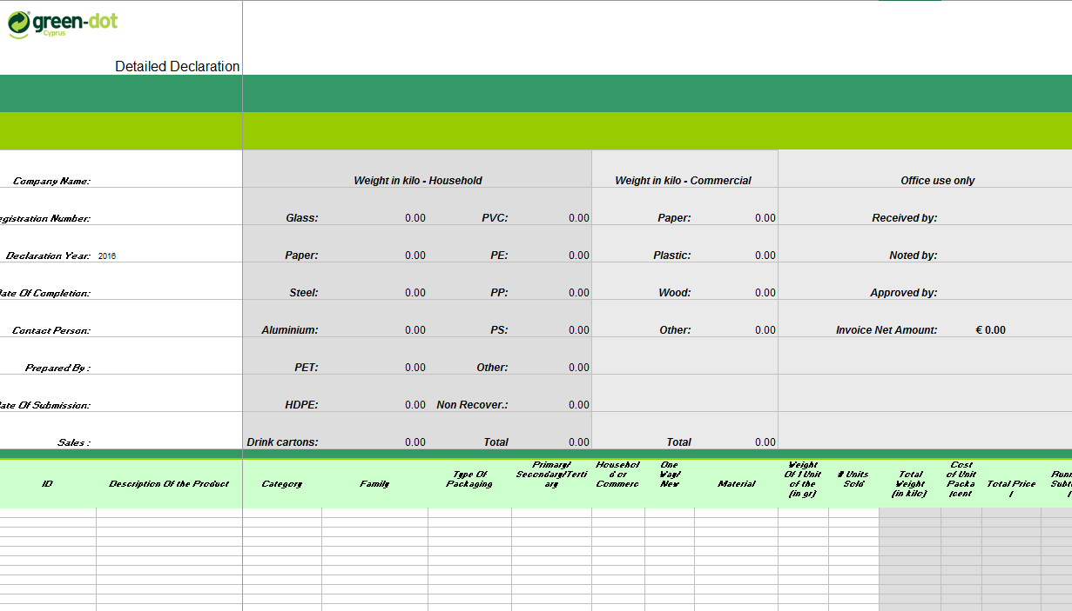

Initials

13

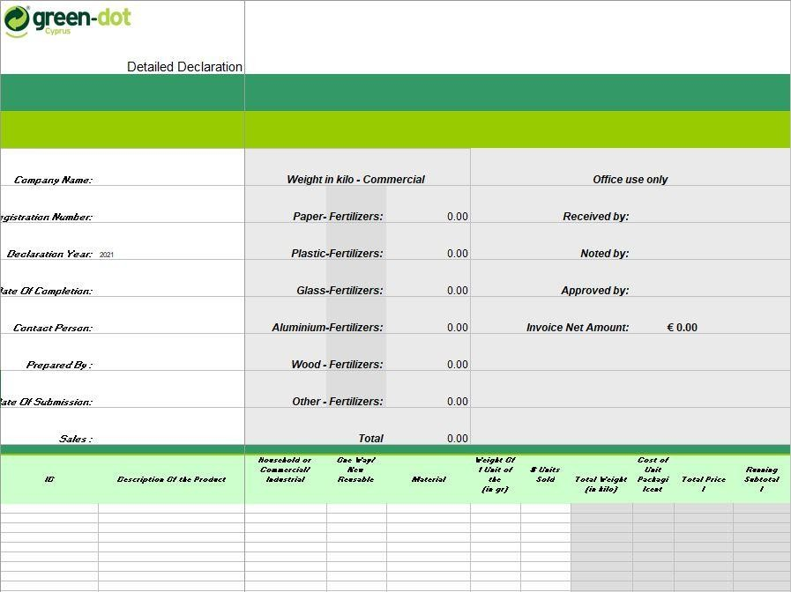

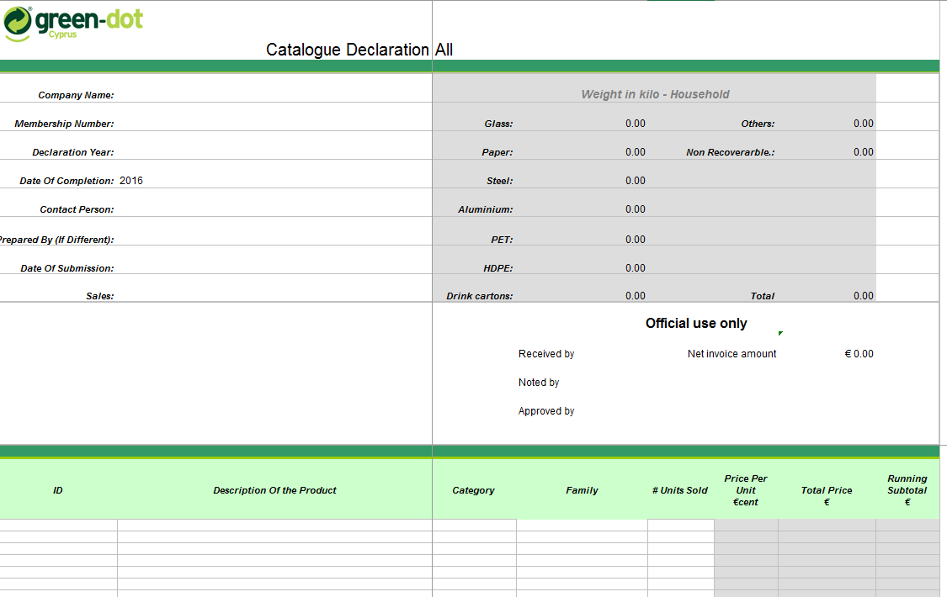

Initials

15

ANNEX I
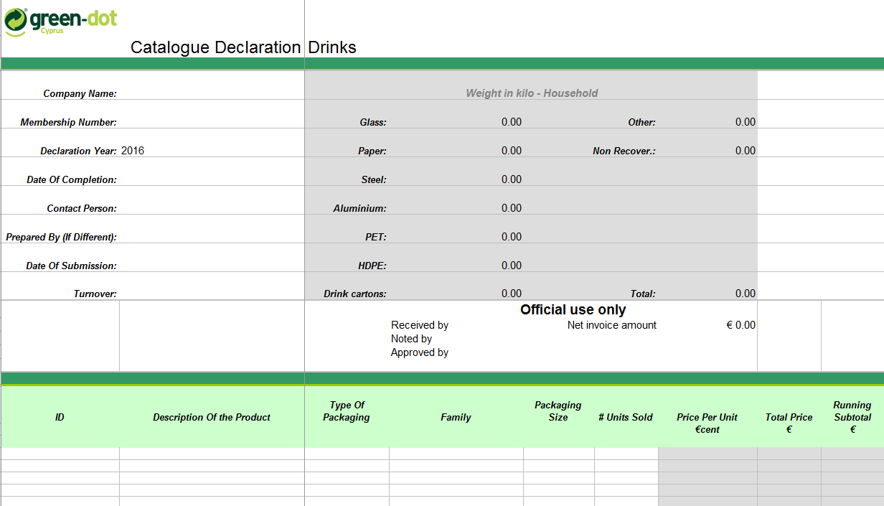

ANNEX I(e) Declaration with Categorization

GREEN DOT (CYPRUS) PUBLIC CO LTD
Mr. Mario Vrahimi
P.O Box: 25463, 1310 Nicosia

Sirs,

Subject: Submission of Packaging Declaration for the year 2021
Company’s Registration No.:................

(Date)

With regards to the above subject, we would like to inform you that our company (Company’s Name) according to our last year’s Declaration, falls into one of the following statistical categories. Therefore we present below details for our turnover.

Previous Year | Declaration Year | Difference (%)

The total amount of the Packaging Contributions based on the following categorization is
€… plus VAT.

Category | Tonne | Cost per Year  (€) | √
 |  | 2021
1 | 0-1 | 100
2 | 1-2 | 142.5
3 | 2-5 | 237.5
4 | 5-10 | 570
5 | 10-25 | 1.045
6 | 25-50 | 1.900
We realise that Green Dot Cyprus and / or the Competent Authorities reserve the right to request clarifications, or carry out a check (audit) of our Declaration with a visit to our premises.

With regards,
Full Name 17
Position

ANNEX II
System Fee Catalogue

TYPE OF PACKAGING | 2017-2021  € Per Tonne
Household Packaging
Glass | 27,61
Carton | 44,78
Metal | 90,62
Aluminium | 20,31
PET | 100,60
HDPE | 100,60
Cardboard Liquid Containers | 116,61
Other reusable | 124,50
Other non reusable | 149,41
Commercial/Industrial Packaging
Corrugated carton | 41,14
Plastic | 36,05
Wood | 11,80
Other | 47,76

Pesticides Packaging | € Per Tonne
Primary Pesticides Packaging that comes in contact with pesticides | 380,00

Gas Cylinder | € Per piece
Steel Cylinder | 1,00
Plastic Cylinder | 1,00

18

ANNEX III

Basic rules for use of the Green Dot Mark
The Mark must be visible on the sales packaging and clearly recognisable (primary packaging).
The Mark may not be modified. It must be used in full. The Mark may not be completed with text or with other graphic elements without the explicit, prior and written permission of Green Dot Cyprus.

Presentation
The Mark is composed of a circle with two arrows which are interweaved along a vertical axis.

Vertical axis of the Mark

Upper part

Lower part

Colours
If the Packaging Responsible chooses to use colours, the following colours shall be used: on a white background, Pantone 367 for the light green arrow pointing to the left, Pantone 363 for the dark green arrow pointing to the right.

Equivalents for four-colour printing Pantone 367 Pantone 363
Cyan: 30% Cyan: 76%
Magenta: 0% Magenta: 0%
Yellow: 60% Yellow: 100%
Black: 0% Black: 23%

Arrow pointing to the right (always the darkcolour)
Arrow pointing to the left (always the light colour)

Initials

19

The vertical axis shall be perpendicular to the text on the packaging.

Colour modifications
The Mark can be used in one colour on a white background, on a coloured background or left blank in one colour.
Right pointing arrow in one colour, on white background (or background in another colour).
Background and right pointing arrow in one colour, left pointing arrow left open in white or in another colour.
Background in colour, mark in official colours Pantone 367 / Pantone 263.

Dimensions
To guarantee immediate identification and optimum visibility of the Mark, a height of 10 mm is suggested and a minimum of 6 mm on small packaging items is accepted.

Techniques for applying the Mark
Printing on the packaging, including labels: offset, screen printing, photogravure, etc. Impressed onto the material using a raised or recessed technique: stamping, embossing, etc.

Deviations
All exceptions to these rules for technical or legal reasons must be recorded in a specific supplementary agreement.

20

